MUSIC APP DOCUMENTATION

July 9-12, 2018

I’ve brainstormed about what App I will be developing. I came up with three app proposals and end up choosing the Music app based on the advice of my adviser Sir Paolo.

Music App  
A handy app for musicians in making or playing their choice of songs. It is an archive of songs to which musicians can view and edit. It provides essential music tools such as a tuner for tuning instruments and tempo as beat guide.

Functionalities

* Store, edit or delete information (Lyrics and chords) in database
* Easy drag and drop chords on lyrics
* Able to change key or transpose the chords
* Can specify the arrangement of songs
* Accelerometer for sensing sounds essential for tuning instruments.
* Tempo calibrator to identify the tempo of your song.
* Share your edited song files to other users.

Sir Paolo’s Questions:

Storing Lyrics / Chords in Database;

o What is the form your data will take? I believe there may be a way of representing notes / chords numerically.

**Most of the musicians today are not able to read music sheets so by making a simple paragraph of lyrics with added chords on top would be helpful. The chords can change depending on the key chord that has a scale degree of chords.**

o Now if you are storing lyrics / chords into the local storage of the device, you will need to determine processes and procedures around this since device storage is limited.

**I believe the app would mostly use text files so it won’t take much data that’s why I’ll be using SQLite and store the data locally.**

•  For drag and drop chords; how will you determine the segmentation and grid?

**There will be a button with a key chord that can expand to show its child chords to which the user can choose from. There will be fixed padding spaces on top of the lyrics to put the chords. Also the chords cannot overlap.**

•  For the keys and transposition; this is interesting and if chords are represented numerically then a simple enough operation.

**The keys can be transposed per song. Yes the chords will be represented in scales or numerically.**

•  How do you define changing the arrangement?

**The user can assign names for each section or paragraph of the song. For example the user will name the first paragraph verse 1. The sections can also be dragged to other positions for it to be arranged according to the user. The user can also make line up of songs and can change the arrangement of the songs.**

•  For the tuning aspect; is it accelerometer or microphone that you want to leverage?

o Each particular approach has their own PROS and CONS

**I’m confused sir I thought microphone is a form of accelerometer. If that’s the case then I’ll be using the microphone as my leverage. Disadvantage of the tuner is the capability and fineness of the user’s mobile device’s frequency detector through microphone. Because phones can easily be accessed and most of the time it’s with us, this is an advantage to musicians who isn’t capable of tuning with their ears and for people who doesn’t want to spend money on tuner devices.**

•  For tempo; what would be your method of detection?

**The method of identifying the songs tempo would be by tapping a button according to the timing of the user until it settles to a number or bpm (beat per minute). By then users can follow the tempo of the phone either through listening or by following the flickering led light on phone.**

Core functionalities:

* Efficient editing of songs using drag and drop functionalities
* Tuner to be determined if it functions with the accelerometer or microphone
* Tempo calibrator/identifier (user generated either by inputting value of beat or through tapping screen to calibrate)

Future functionalities are to be determined during the development process.

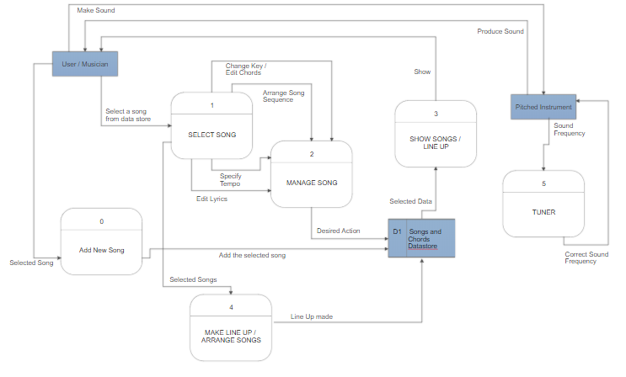**Diagram 0 MUSIC APP**

July 13-23, 2018

I developed the app’s layout and also it’s drag and drop functionality. **I got stuck with the auto divide song’s section.**